CS5551 Advanced Software Engineering Lab Assignment #5

***Mashup of Google Maps and Flickr API in Ionic framework which emulates on web and mobile***

***Technology used:*** Angular JS, HTML/CSS, JavaScript

Building the app from command prompt through ionic frame work

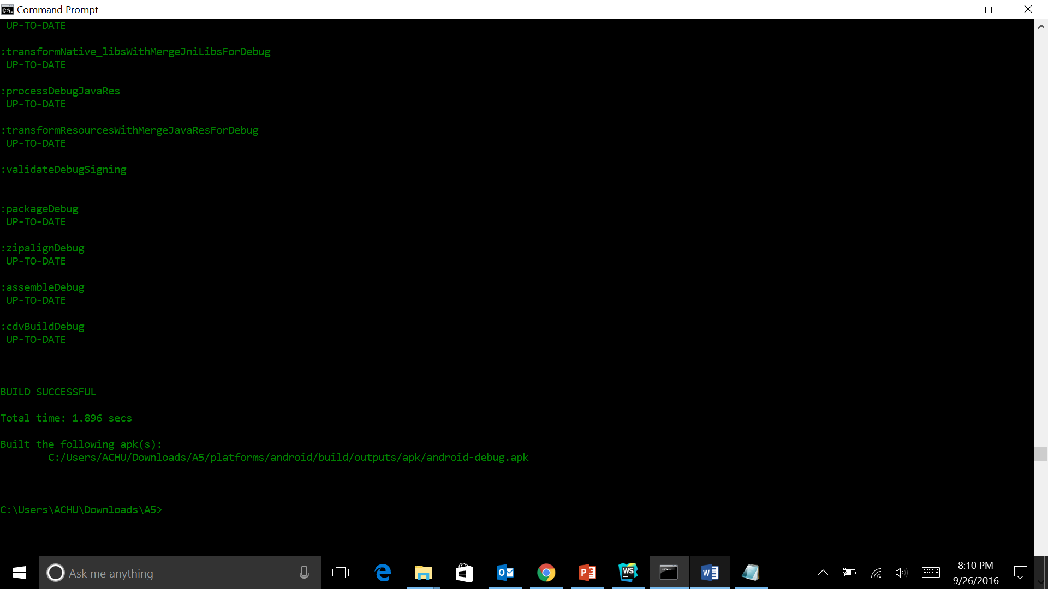

Building the app and launching it on the Android emulator

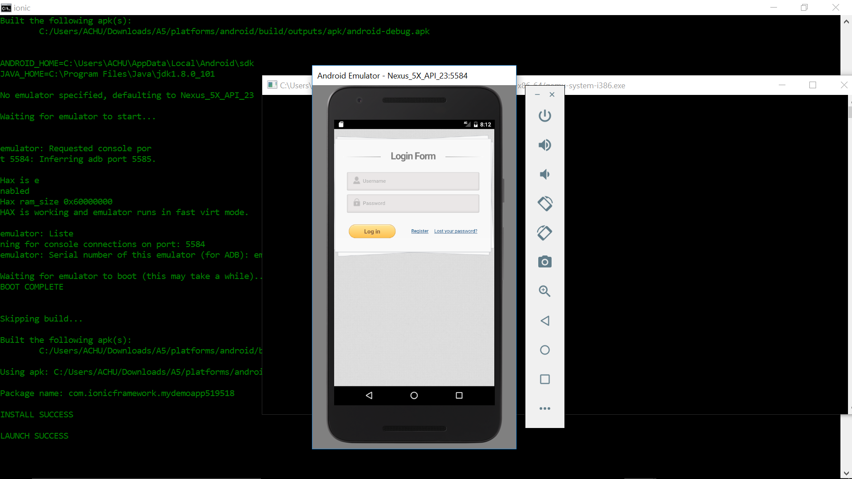

**Screenshots:** Here the screen shots on both mobile emulator device and web browser

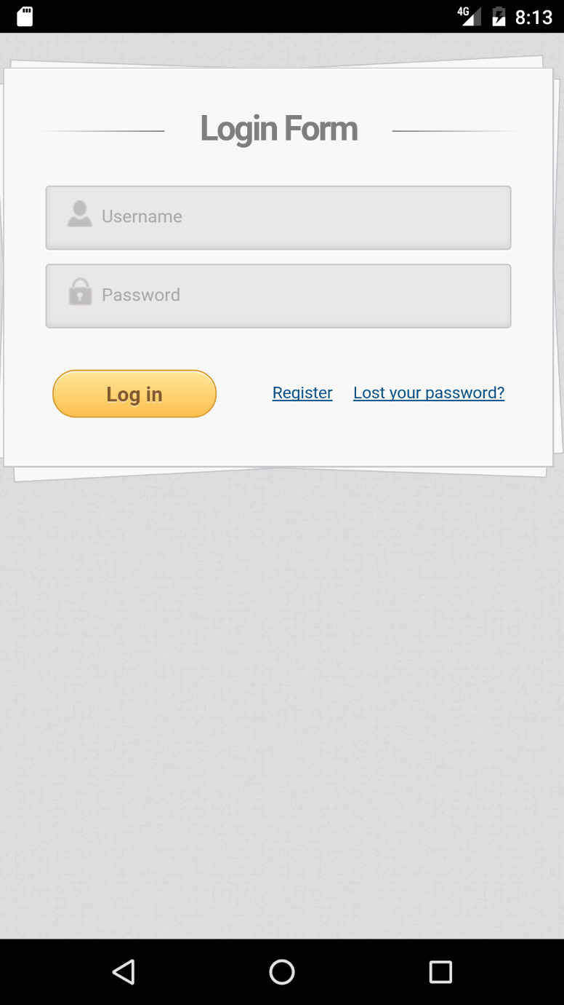

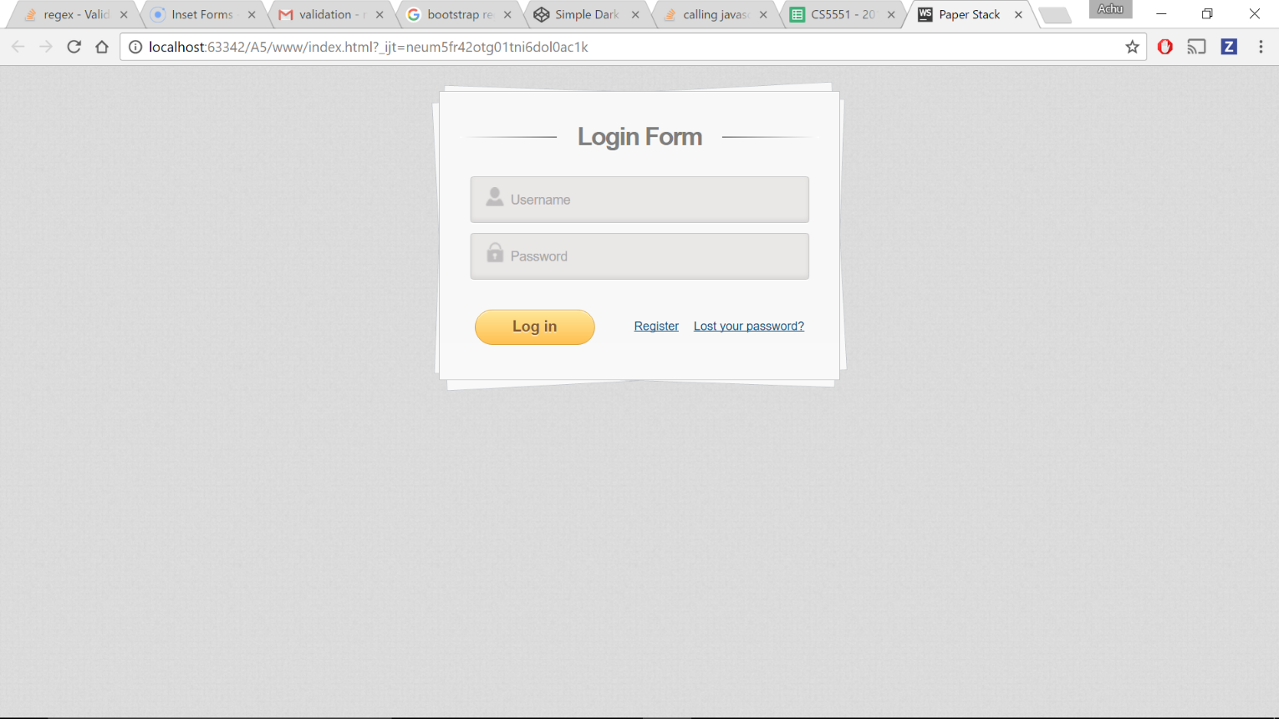

Below screen shots show the input validation of username and password.

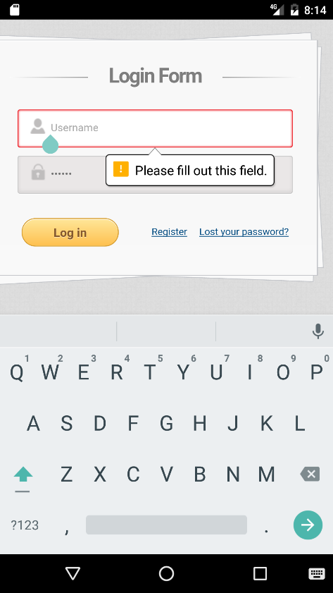

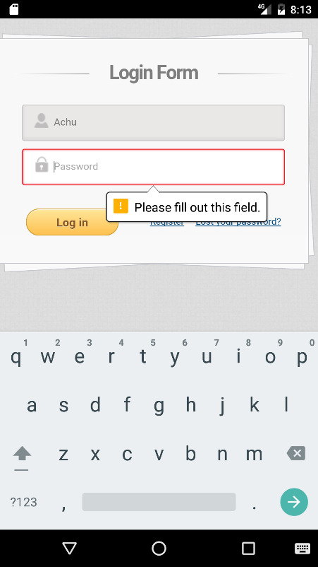

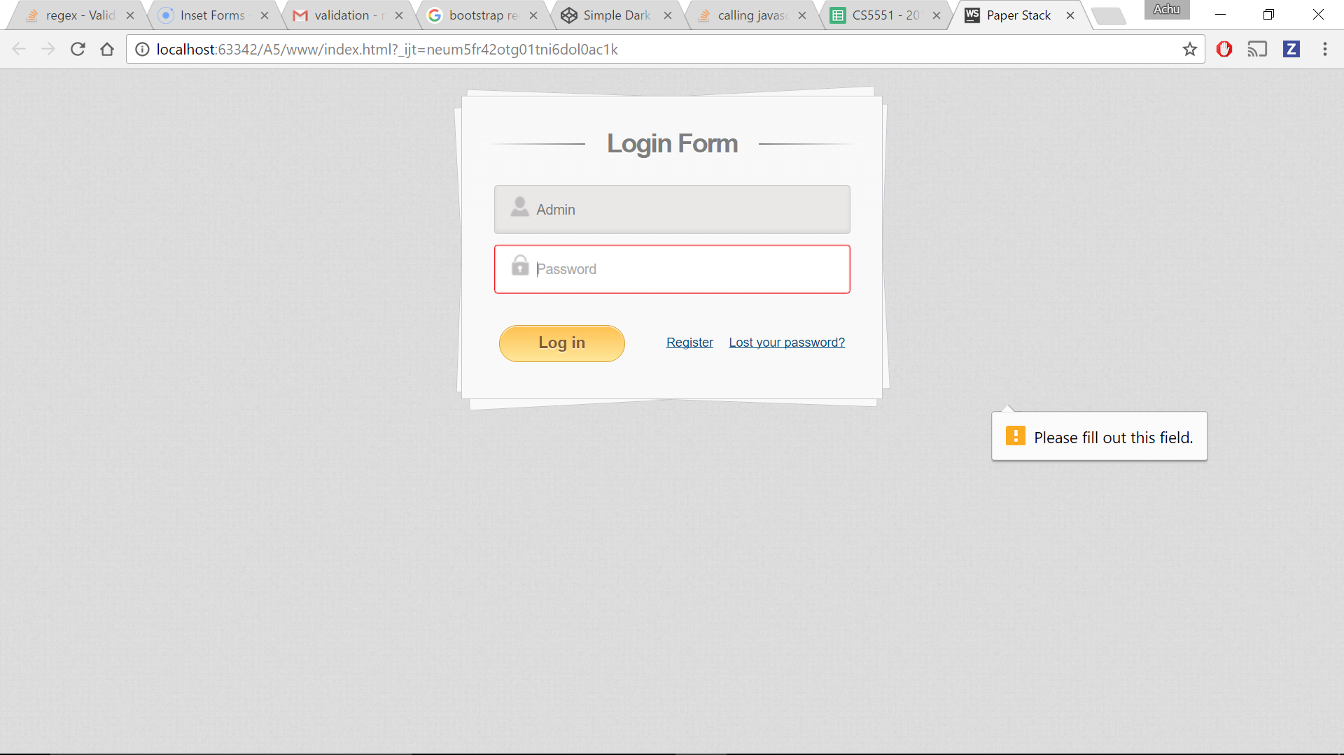

Once the input credentials are correct it redirects to home page:

Here two mashups of both Google maps and Flickr which retrieves popular (trending) images on the selected cities.

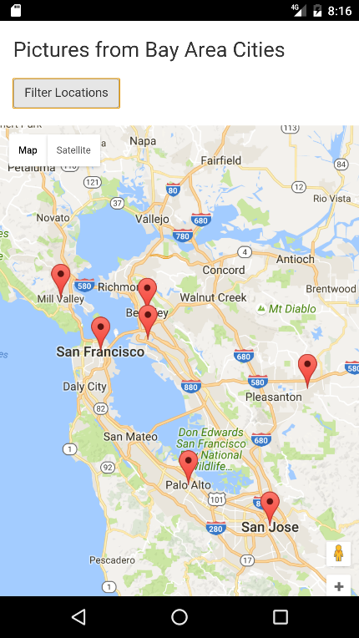

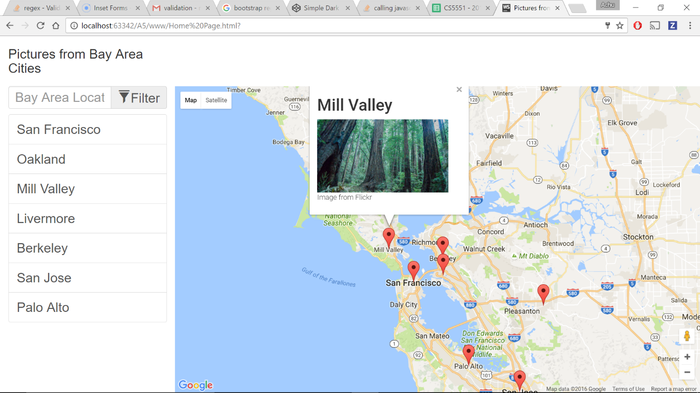

Below shows the drop down list of cities populated from google maps

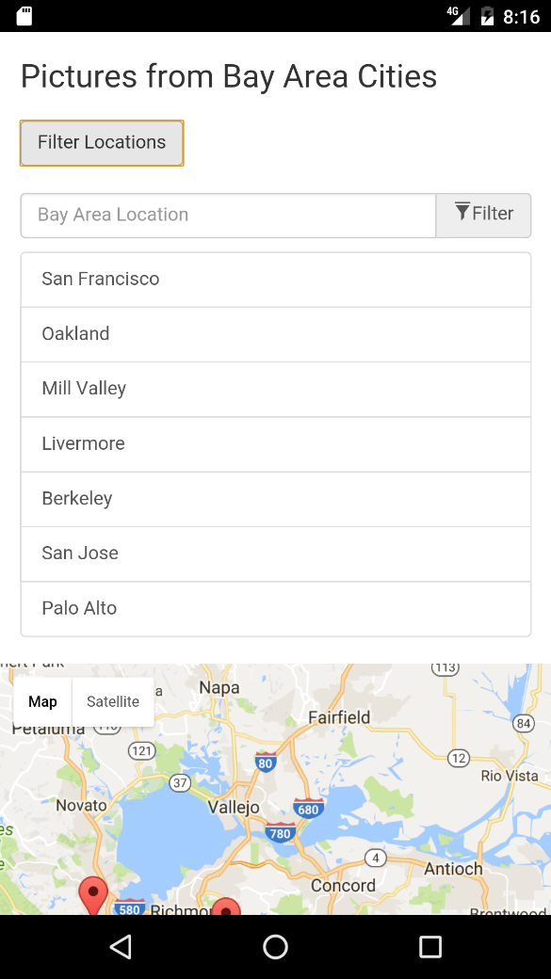

Below images shows trending photos of various cities like Mill valley, Sanfrancisco, Sanjose, Palo Alto etc.

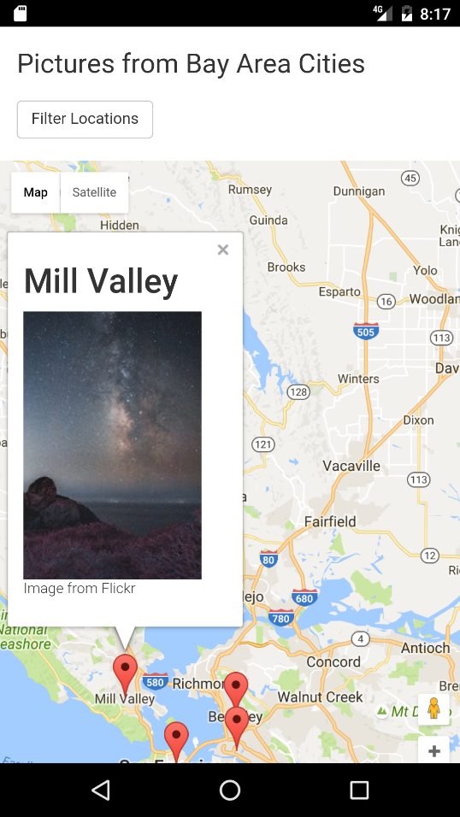 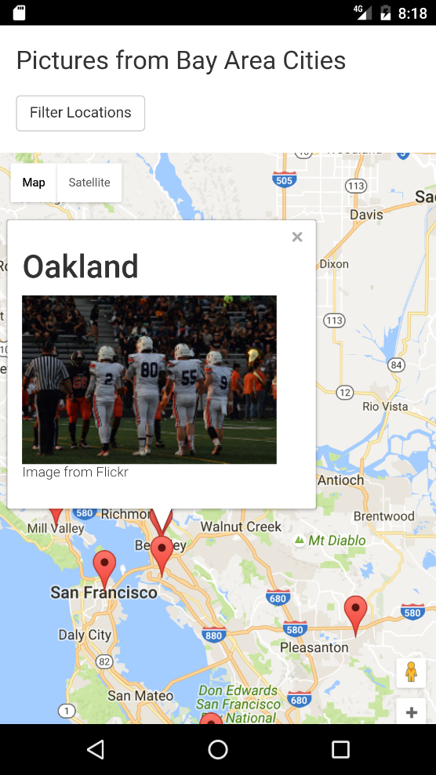

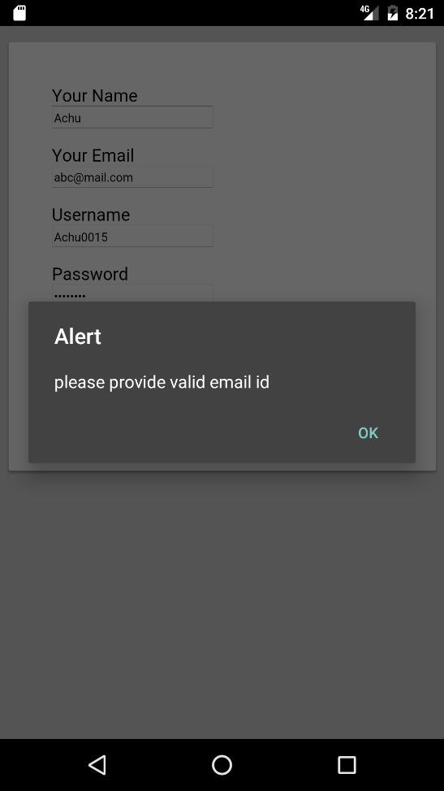 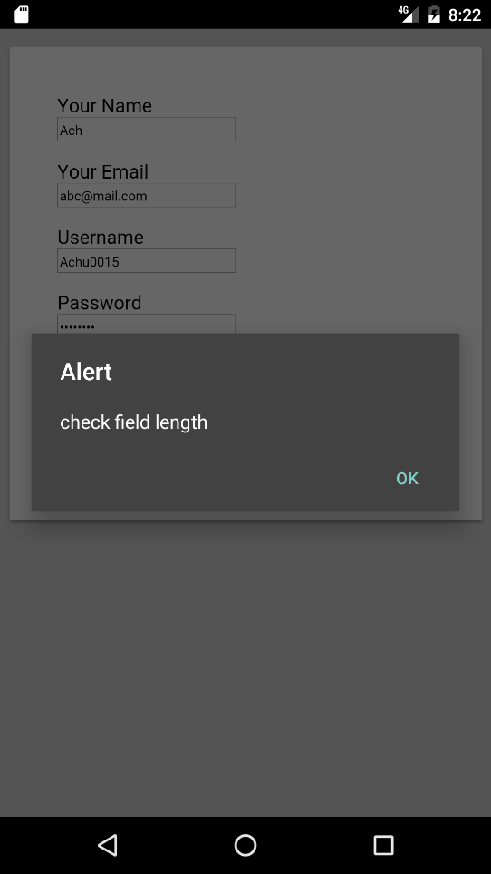

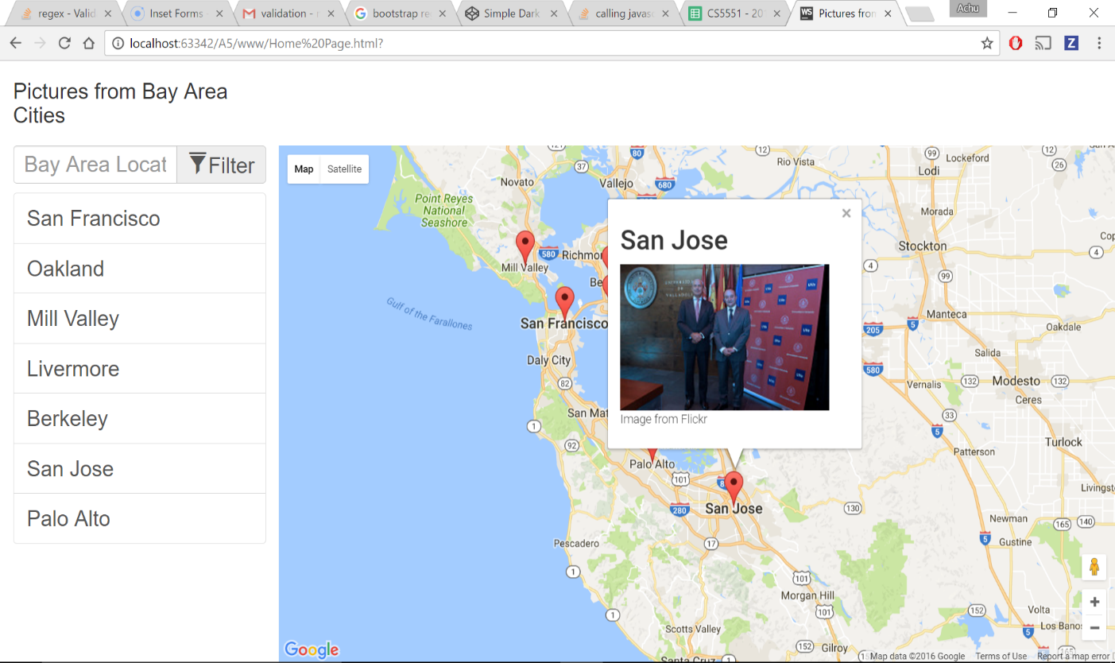

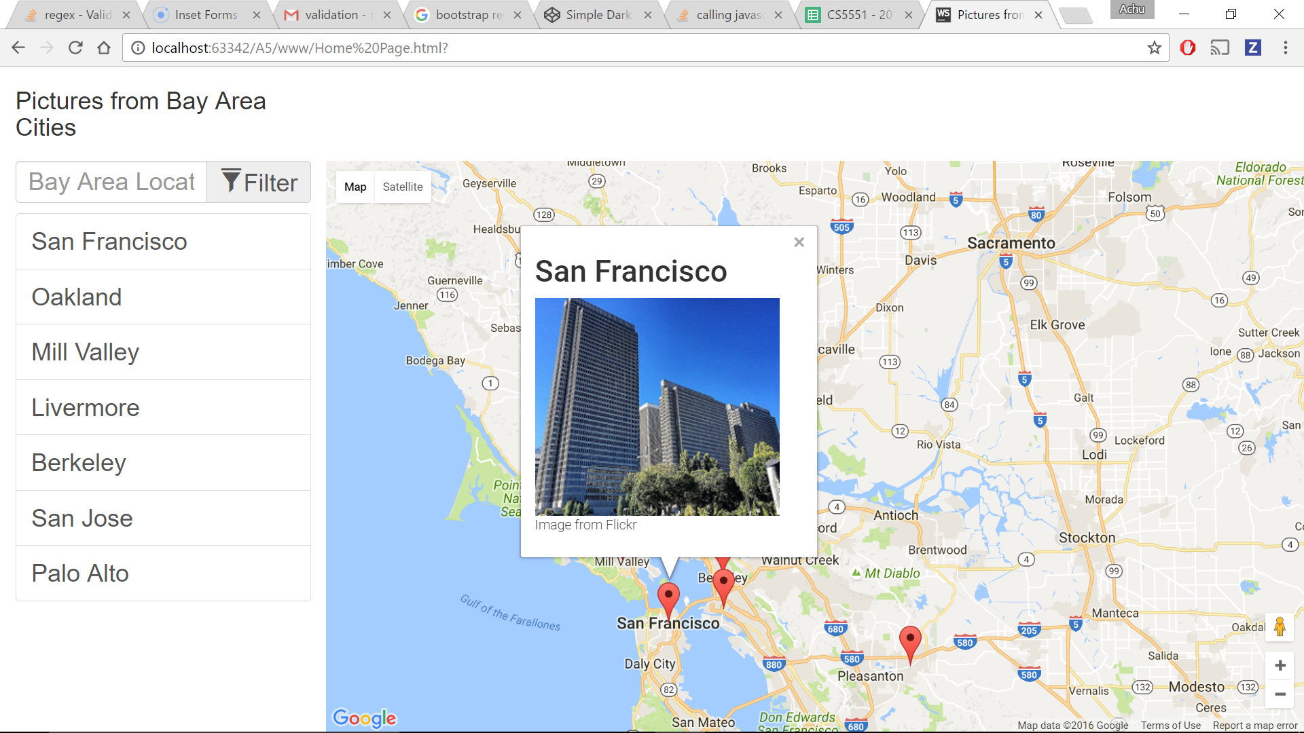

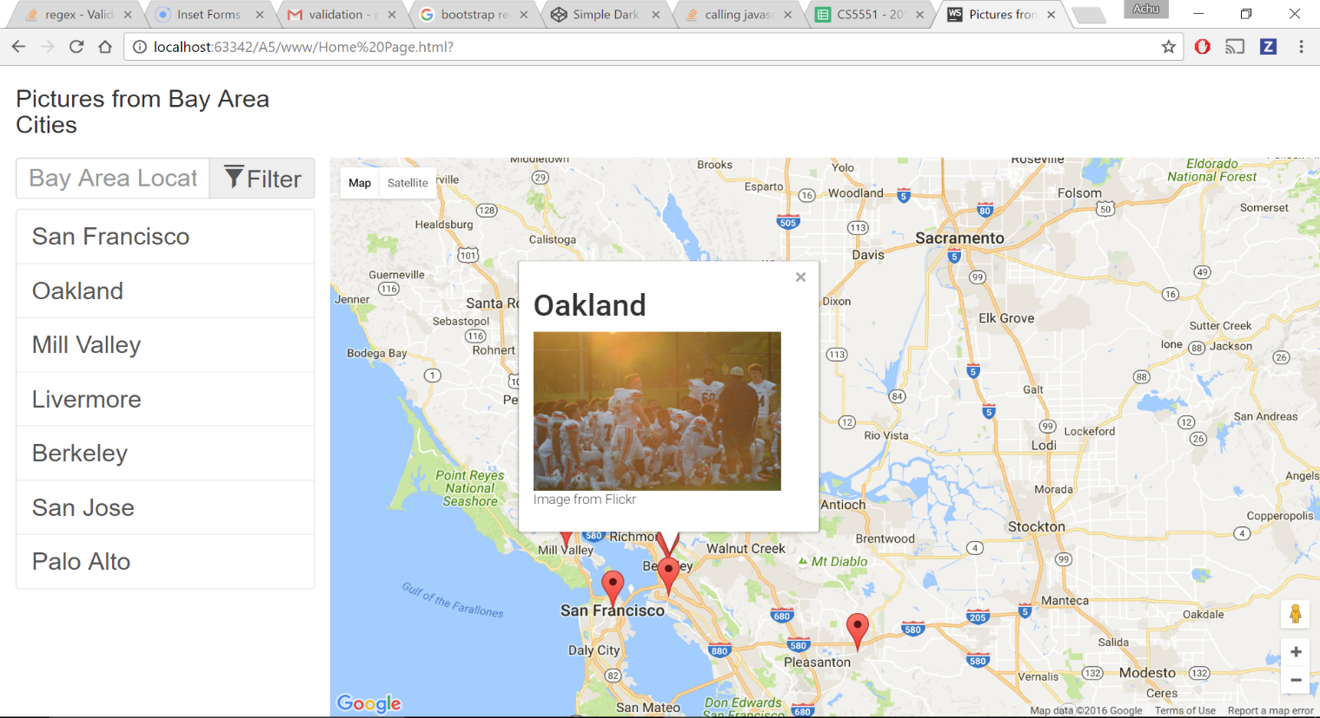

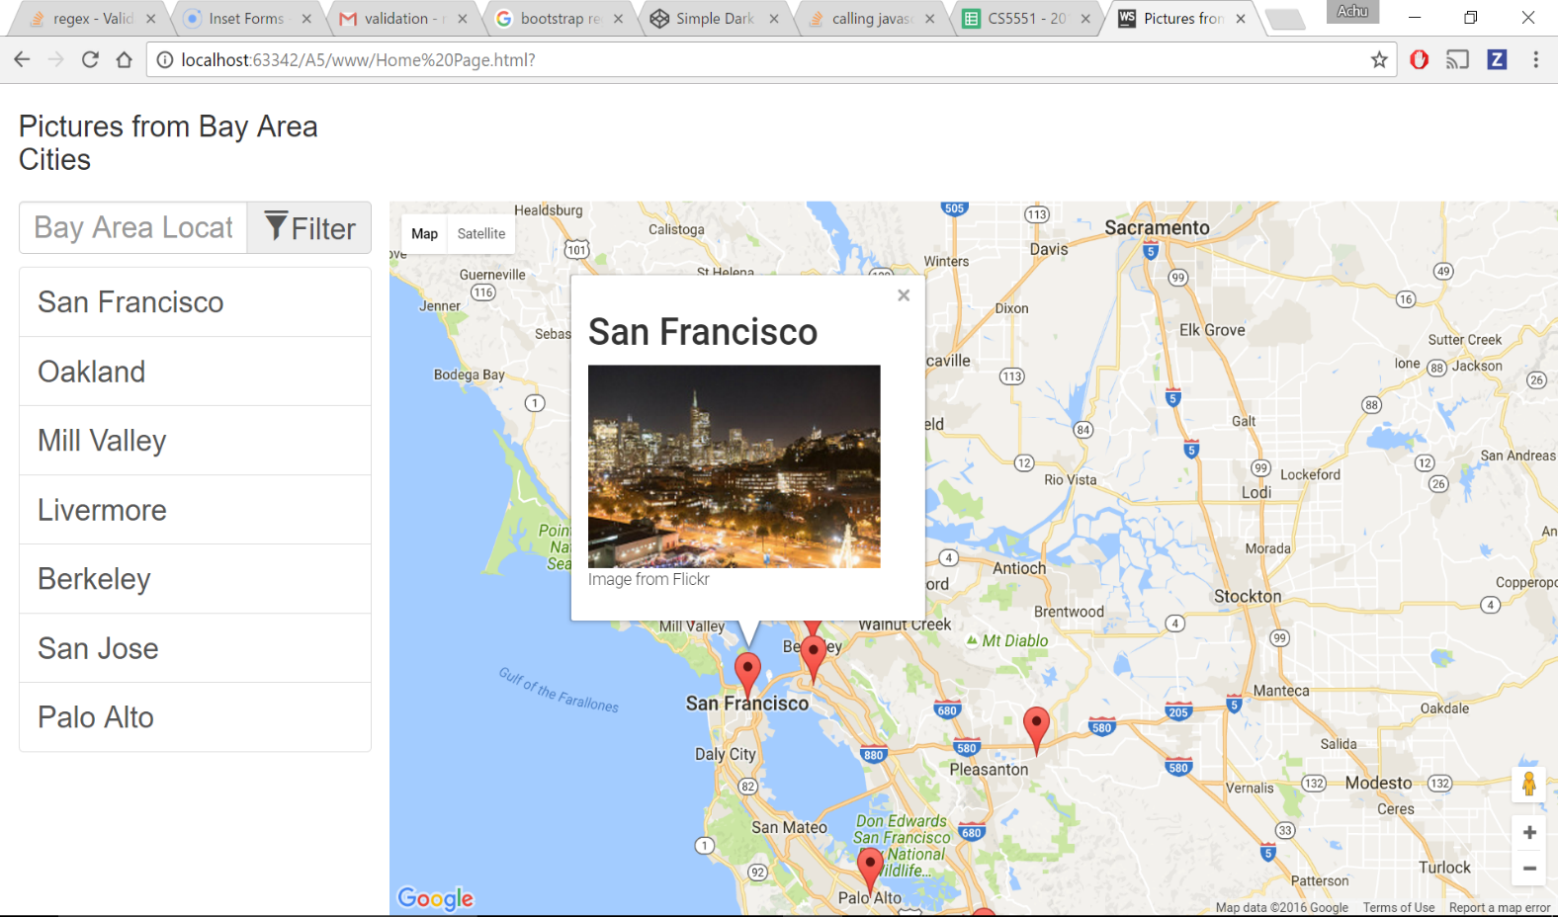

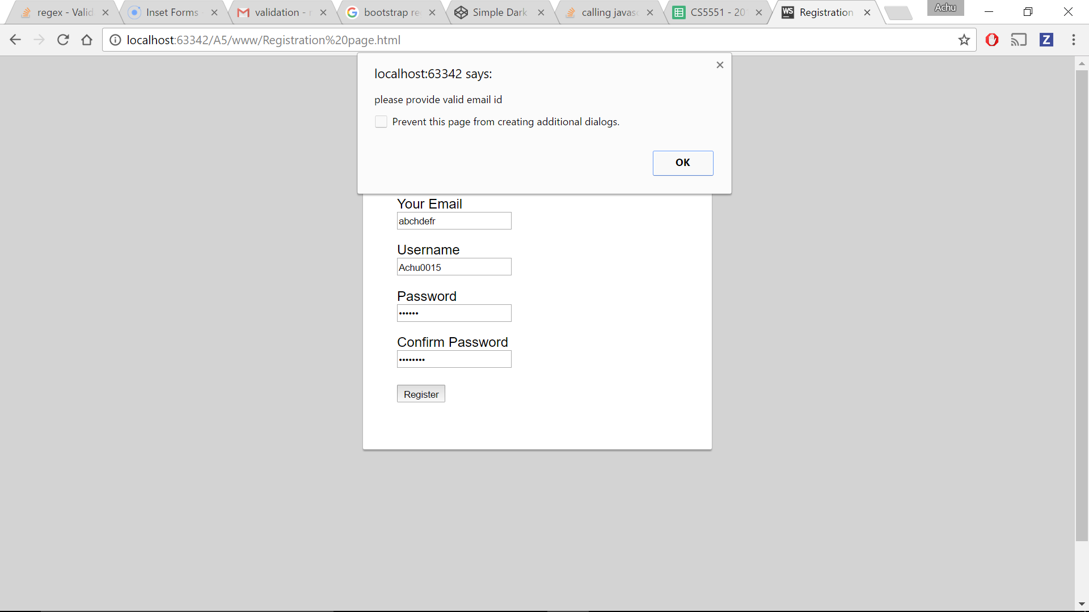

Google Maps uses Flickr API to render the images particular to that city.

**References:**

* <http://www.flickr.com/services/api/flickr.photos.search.html>
* <http://ionicframework.com/docs/components/#inset-forms>
* <https://developers.google.com/maps/>
* Class Tutorial